

BATCH AND ROLL NO:
EXPERIMENT NO.5
TITLE: Design a mobile application to create different dialog boxes and menu Popup, option context.
DATE OF PERFORMANCE
DATE OF CHECKING

Title: Design a mobile application to create different dialog boxes and menu Popup, option context.

Requirements:
- Android Studio Theory:
In android, the Menu is an important part of the UI component which is used to provide some common functionality around the application. With the help of the menu, users can experience smooth and consistent experiences throughout the application.
In Android, we have three types of Menus available to define a set of options and actions in our android applications.
The Menus in android applications are the following:

  - Android Options Menu: Android Options Menu is a primary collection of menu items in an android application and is useful for actions that have a global impact on the search application.
  - Android Context Menu: Android Context Menu is a floating menu that only appears when the user clicks for a long time on an element and is useful for elements that affect the selected content or context frame.
  - Android Popup Menu: Android Popup Menu displays a list of items in a vertical list which presents the view that invoked the menu and is useful to provide an overflow of actions related to specific content.

Steps for Option Menu

- Create a New project in Android Studio
- Working with the XML Files, go to the activity_main.xml file, which represents the UI of the project. Make the code for the activity_main.xml file according to your requirements.
- Create Menu Directory and Menu File-First we will create a menu director which will contain the menu file. Go to app > res> right-click > New > Android Resource Directory and give the Directory name and Resource type as menu. WE will create a popup menu file inside that menu resource directory. Go to app > res > menu>right-click> New> Menu Resource File and create a menu resource file and name it popup-Menu. In the popup_mennu file, we will add menu item.



Code:
- activity_main.xml


<?xml version="1.0" encoding="utf-8"?>
<androidx.coordinatorlayout.widget.CoordinatorLayout
xmlns:android="http://schemas.android.com/apk/res/android"
xmlns:app="http://schemas.android.com/apk/res-auto"
android:layout_width="match_parent"
android:layout_height="match_parent">
<com.google.android.material.appbar.AppBarLayout
android:layout_width="match_parent"
android:layout_height="wrap_content">
<androidx.appcompat.widget.Toolbar
android:id="@+id/toolbar"
android:layout_width="match_parent"
android:layout_height="?attr/actionBarSize"
android:background="?attr/colorPrimary"
app:title="Dialog Box &amp; Menu"
android:layout_marginTop="30dp"
app:titleTextColor="@android:color/white"/>
</com.google.android.material.appbar.AppBarLayout>
<androidx.core.widget.NestedScrollView
android:layout_width="match_parent"
android:layout_height="match_parent"
app:layout_behavior="@string/appbar_scrolling_view_behavior">
<LinearLayout
android:layout_width="match_parent"
android:layout_height="wrap_content"
android:orientation="vertical"
android:padding="16dp">
<com.google.android.material.card.MaterialCardView
android:layout_width="match_parent"
android:layout_height="wrap_content"
android:layout_marginBottom="16dp"
app:cardElevation="4dp"
app:cardCornerRadius="8dp">
<LinearLayout
android:layout_width="match_parent"
android:layout_height="wrap_content"
android:orientation="vertical"
android:padding="16dp">
<TextView
android:layout_width="wrap_content"
android:layout_height="wrap_content"
android:text="Dialog Boxes"
android:textAppearance="?attr/textAppearanceHeadline6"
android:layout_marginBottom="16dp"/>
<com.google.android.material.button.MaterialButton
android:id="@+id/btnSimpleDialog"
android:layout_width="match_parent"
android:layout_height="wrap_content"
android:text="Show Simple Dialog"/>
<com.google.android.material.button.MaterialButton
android:id="@+id/btnCustomDialog"
android:layout_width="match_parent"
android:layout_height="wrap_content"
android:text="Show Custom Dialog"/>
</LinearLayout>
</com.google.android.material.card.MaterialCardView>
<com.google.android.material.card.MaterialCardView
android:layout_width="match_parent"
android:layout_height="wrap_content"
android:layout_marginBottom="16dp"
app:cardElevation="4dp"
app:cardCornerRadius="8dp">
<LinearLayout
android:layout_width="match_parent"
android:layout_height="wrap_content"
android:orientation="vertical"
android:padding="16dp">
<TextView
android:layout_width="wrap_content"
android:layout_height="wrap_content"
android:text="Long Press Items"
android:textAppearance="?attr/textAppearanceHeadline6"
android:layout_marginBottom="16dp"/>
<ListView
android:id="@+id/listView"
android:layout_width="match_parent"
android:layout_height="200dp"/>
</LinearLayout>
</com.google.android.material.card.MaterialCardView>
</LinearLayout>
</androidx.core.widget.NestedScrollView>
<com.google.android.material.floatingactionbutton.FloatingActionButton
android:id="@+id/fab"
android:layout_width="wrap_content"
android:layout_height="wrap_content"
android:layout_gravity="bottom|end"
android:layout_margin="16dp"
android:src="@android:drawable/ic_dialog_info"/>
<TextView
android:id="@+id/tvRollNumber"
android:layout_width="wrap_content"
android:layout_height="wrap_content"
android:text="Roll No:42308"
android:layout_gravity="bottom|start"
android:layout_margin="16dp"
android:textStyle="bold"/>
</androidx.coordinatorlayout.widget.CoordinatorLayout>

- menu/context_menu.xml
<?xml version="1.0" encoding="utf-8"?>
<menu xmlns:android="http://schemas.android.com/apk/res/android">
<item
android:id="@+id/action_edit"
android:title="Edit"/>
<item
android:id="@+id/action_delete"
android:title="Delete"/>
<item
android:id="@+id/action_share"
android:title="Share"/>
</menu>


- menu/main_menu.xml

<?xml version="1.0" encoding="utf-8"?>
<menu xmlns:android="http://schemas.android.com/apk/res/android"
xmlns:app="http://schemas.android.com/apk/res-auto">
<item
android:id="@+id/action_settings"
android:title="Settings"
android:icon="@android:drawable/ic_menu_manage"
app:showAsAction="never"/>
<item
android:id="@+id/action_search"
android:title="Search"
android:icon="@android:drawable/ic_menu_search"
app:showAsAction="ifRoom"/>
<item
android:id="@+id/action_about"
android:title="About"
app:showAsAction="never"/>
</menu>

- dialog_cutom.xml
<?xml version="1.0" encoding="utf-8"?>
<LinearLayout xmlns:android="http://schemas.android.com/apk/res/android"
android:layout_width="match_parent"
android:layout_height="wrap_content"
android:orientation="vertical"
android:padding="16dp">
<com.google.android.material.textfield.TextInputLayout
android:layout_width="match_parent"
android:layout_height="wrap_content"
android:hint="Enter your name">
<com.google.android.material.textfield.TextInputEditText
android:id="@+id/editTextName"
android:layout_width="match_parent"
android:layout_height="wrap_content"
android:inputType="textPersonName"/>
</com.google.android.material.textfield.TextInputLayout>
<com.google.android.material.textfield.TextInputLayout
android:layout_width="match_parent"
android:layout_height="wrap_content"
android:hint="Enter your email"
android:layout_marginTop="8dp">
<com.google.android.material.textfield.TextInputEditText
android:id="@+id/editTextEmail"
android:layout_width="match_parent"
android:layout_height="wrap_content"
android:inputType="textEmailAddress"/>
</com.google.android.material.textfield.TextInputLayout>
</LinearLayout>

- MainActivity.java
package com.example.exp5;
import android.os.Bundle;
import android.view.ContextMenu;
import android.view.Menu;
import android.view.MenuItem;
import android.view.View;


import android.widget.ArrayAdapter;
import android.widget.ListView;
import android.widget.Toast;
import androidx.appcompat.app.AlertDialog;
import androidx.appcompat.app.AppCompatActivity;
import androidx.appcompat.widget.Toolbar;
import com.google.android.material.dialog.MaterialAlertDialogBuilder;
import com.google.android.material.floatingactionbutton.FloatingActionButton;
import com.google.android.material.snackbar.Snackbar;
import java.util.Arrays;
import java.util.List;
public class MainActivity extends AppCompatActivity {
private ListView listView;
private List<String> items = Arrays.asList(
"Item 1", "Item 2", "Item 3", "Item 4"
);
@Override
protected void onCreate(Bundle savedInstanceState) {
super.onCreate(savedInstanceState);
setContentView(R.layout.activity_main);
// Setup toolbar
Toolbar toolbar = findViewById(R.id.toolbar);
setSupportActionBar(toolbar);
// Initialize views
listView = findViewById(R.id.listView);
FloatingActionButton fab = findViewById(R.id.fab);
// Setup ListView
ArrayAdapter<String> adapter = new ArrayAdapter<>(
this,
android.R.layout.simple_list_item_1,
items
);
listView.setAdapter(adapter);
registerForContextMenu(listView);
// Setup click listeners
findViewById(R.id.btnSimpleDialog).setOnClickListener(v -> showSimpleDialog());
findViewById(R.id.btnCustomDialog).setOnClickListener(v -> showCustomDialog());
fab.setOnClickListener(v -> {
Snackbar.make(v, "This is a Snackbar message", Snackbar.LENGTH_LONG)
.setAction("Action", null)
.show();
});
}
private void showSimpleDialog() {
new MaterialAlertDialogBuilder(this)
.setTitle("Simple Dialog")
.setMessage("This is a simple dialog message")
.setPositiveButton("OK", (dialog, which) -> {
Toast.makeText(this, "OK clicked", Toast.LENGTH_SHORT).show();
})
.setNegativeButton("Cancel", null)
.show();
}
private void showCustomDialog() {
View dialogView = getLayoutInflater().inflate(R.layout.dialog_custom, null);
new MaterialAlertDialogBuilder(this)
.setTitle("Custom Dialog")
.setView(dialogView)


.setPositiveButton("Submit", (dialog, which) -> {
Toast.makeText(this, "Form submitted", Toast.LENGTH_SHORT).show();
})
.setNegativeButton("Cancel", null)
.show();
}
@Override
public boolean onCreateOptionsMenu(Menu menu) {
getMenuInflater().inflate(R.menu.main_menu, menu);
return true;
}
@Override
public boolean onOptionsItemSelected(MenuItem item) {
int id = item.getItemId();
if (id == R.id.action_settings) {
Toast.makeText(this, "Settings selected", Toast.LENGTH_SHORT).show();
return true;
} else if (id == R.id.action_search) {
Toast.makeText(this, "Search selected", Toast.LENGTH_SHORT).show();
return true;
} else if (id == R.id.action_about) {
Toast.makeText(this, "About selected", Toast.LENGTH_SHORT).show();
return true;
}
return super.onOptionsItemSelected(item);
}
@Override
public void onCreateContextMenu(ContextMenu menu, View v, ContextMenu.ContextMenuInfo
menuInfo) {
super.onCreateContextMenu(menu, v, menuInfo);
getMenuInflater().inflate(R.menu.context_menu, menu);
}
@Override
public boolean onContextItemSelected(MenuItem item) {
int id = item.getItemId();
if (id == R.id.action_edit) {
Toast.makeText(this, "Edit selected", Toast.LENGTH_SHORT).show();
return true;
} else if (id == R.id.action_delete) {
Toast.makeText(this, "Delete selected", Toast.LENGTH_SHORT).show();
return true;
} else if (id == R.id.action_share) {
Toast.makeText(this, "Share selected", Toast.LENGTH_SHORT).show();
return true;
}
return super.onContextItemSelected(item);
}
}



Output:

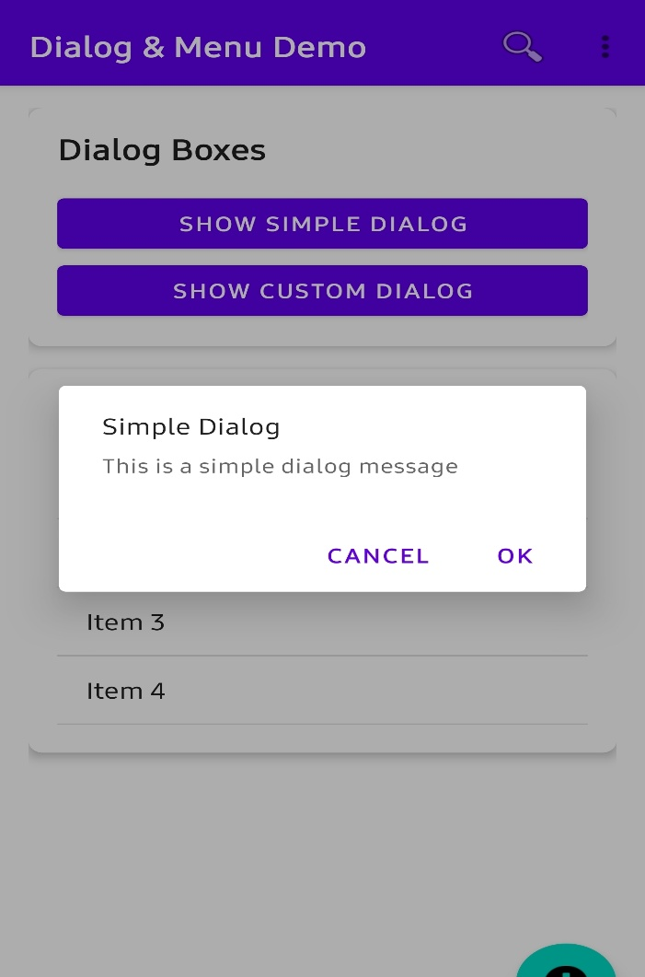 | 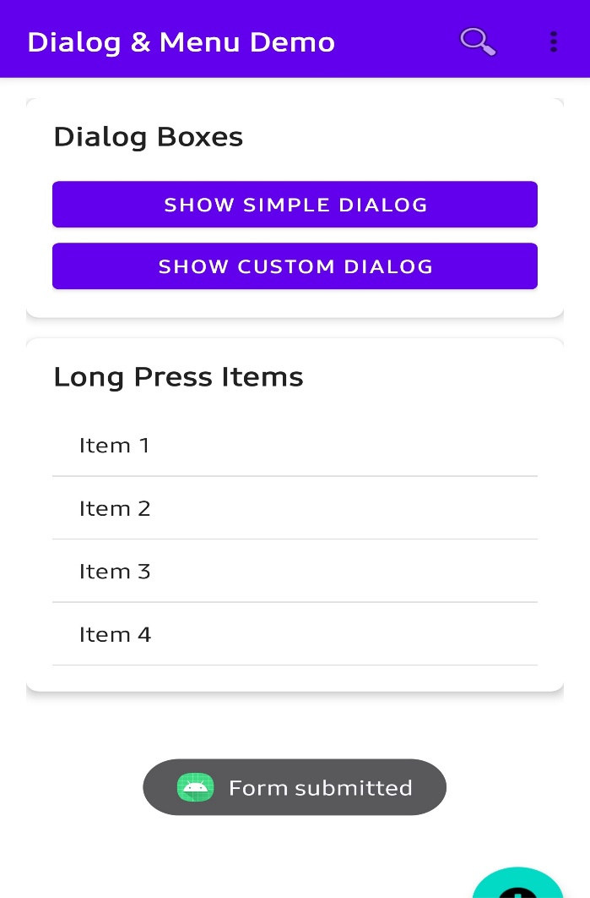
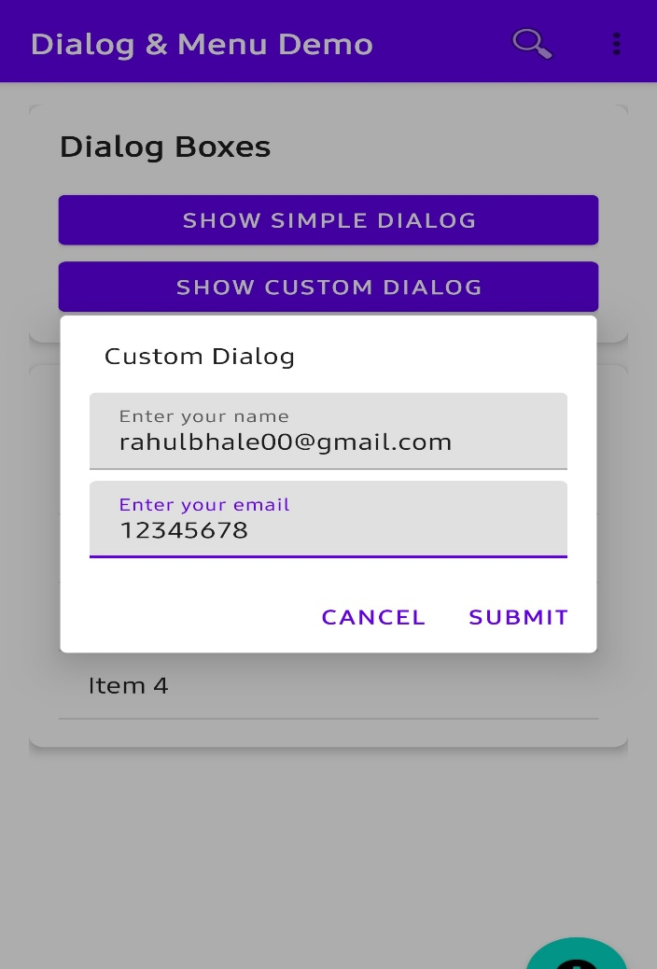 | 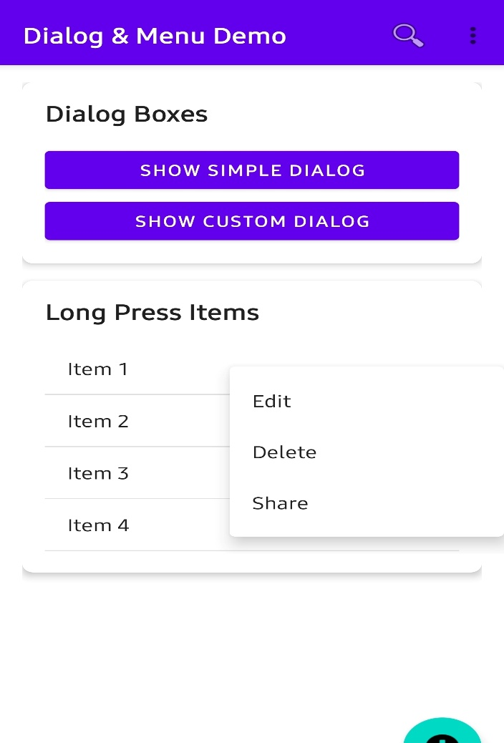
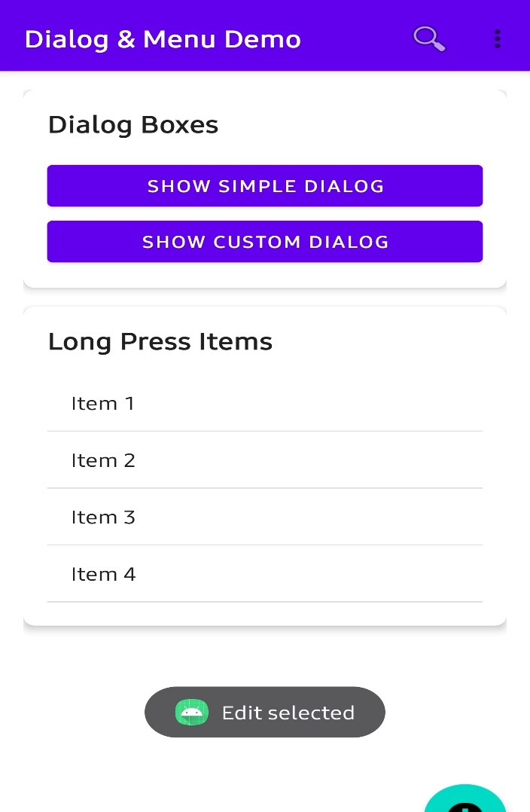 | 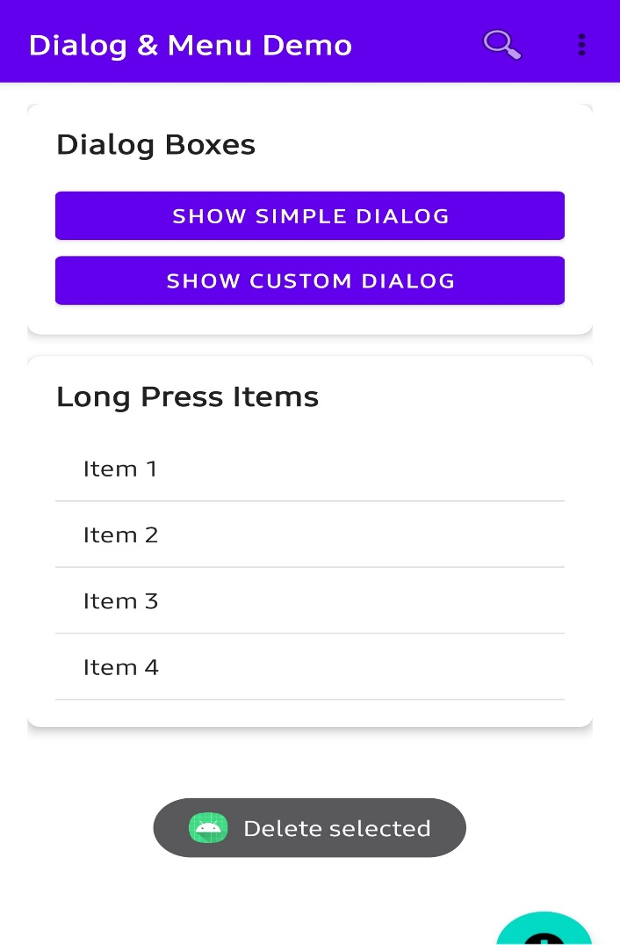


CONCLUSION:

……………………………………………………………………………………………

……………………………………………………………………………………………

……………………………………………………………………………………………

